**Requirement Gathering and Analysis Phase**

**Data Flow Diagram & User Stories**

|  |  |
| --- | --- |
| Date | 6 July 2024 |
| Team ID | SWTID1719933836 |
| Project Name | Connectify |
| Maximum Marks |  |

**Data Flow Diagrams:**

A Data Flow Diagram (DFD) is a traditional visual representation of the information flows within a system. A neat and clear DFD can depict the right amount of the system requirement graphically. It shows how data enters and leaves the system, what changes the information, and where data is stored.

Data Flow Diagram

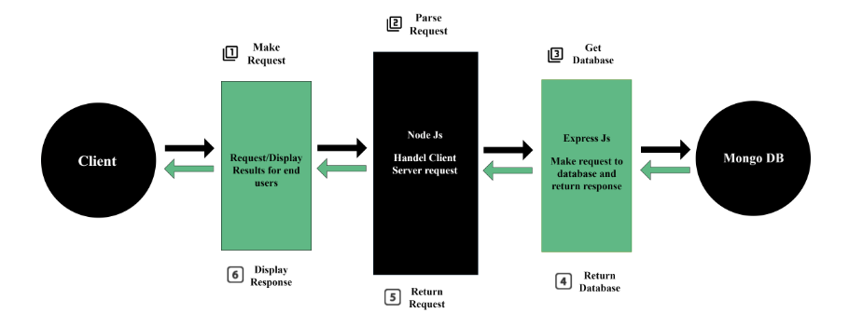

**User Stories**

Use the below template to list all the user stories for the product.

| **User Type** | **Functional Requirement (Epic)** | **User Story Number** | **User Story / Task** | **Acceptance criteria** | **Priority** | **Release** |
| --- | --- | --- | --- | --- | --- | --- |
| Customer (Web user) | Registration | USN-1 | As a user, I can register for the application by entering my email, password, and confirming my password. | I can access create an account and access it | High | Sprint-1 |
|  |  | USN-2 | As a user, I will receive confirmation email once I have registered for the application | I can receive confirmation email & click confirm | High | Sprint-1 |
|  |  | USN-3 | As a user, I can register for the application through Facebook | I can register and access my account with Facebook Login | Low | Sprint-2 |
|  |  | USN-4 | As a user, I can register for the application through Gmail | I can register and access my account with Google Login | Medium | Sprint-1 |
|  | Login | USN-5 | As a user, I can log into the application by entering email & password | I can access my account with the registered email and password | High | Sprint-1 |
|  | Posting | USN-6 | As a user, I can create posts and view other’s posts. | I can create posts on my account and view posts on my feed | High | Sprint-3 |
|  |  | USN-7 | As a user, I can like and comment on posts. | I can like posts and comment on posts | High | Sprint-3 |
|  | Direct Messaging | USN-8 | As a user, I can chat with other users. | I can chat directly with other users | High | Sprint-4 |
|  |  | USN-9 | As a user, I can share posts to other users. | I can share posts to friends and other users | Low | Sprint-4 |
|  | Friends | USN-10 | As a user, I can send and accept friend requests. | I can send friend requests and accept friend requests | High | Sprint-3 |
|  | Account Management | USN-11 | As a user, I can edit my own profile and make it public/private. | I can modify my profile to add information and make my profile public/private | Medium | Sprint-3 |
|  |  | USN-12 | As a user, I can delete my own account. | I can delete my account | Medium | Sprint-2 |